KS5 Sixth Form Careers Notices
Some opportunities may come with a cost so please research
Sunderland University ‘Deep Fakes’ Online Event
Medic Mentor Opportunities
Personal Statement Webinar – Sutton Trust
Careers in Hospitality Insight
NHS Medical & Dentistry
Kent Uni – Exam Stress
KPMG Work Experience
School Leaver Accountancy Job Vacancy
Queen Mary Offers
Apprenticeship Webinar
Royal Town Planning Work Experience opportunity
Dental Work Experience

The Faculty of Technology at the University of Sunderland invite your Year 12 and Year 13 students to join a very special online event on the theme of Deep Fakes. This fascinating topic covers the production of synthetic media, manipulated to make a person’s digital likeness appear to be that of another. Both visual and audio content can be altered by using machine learning and AI, usually maliciously, to portray something entirely false.
Join our expert panel, led by Professor John Murray (Academic Dean of the Faculty of Technology and expert in Human-Robot Interaction and Trust around AI and Machine Learning Systems), who will share his thoughts and ideas on this rapidly developing field.
Participants will have the opportunity to pose questions to the panel (either in advance by email or via the Teams chat box)
Date: 18 May 2023 Times: 5:30pm - 6:30pm Location: online
To book a place at this online event please register here:
https://form.jotform.com/202531653728051

Medic Mentor: I’m Abbie, nurse and Chief Nurse Mentor and AHP Mentor. I’m writing to let you know that I am launching two virtual conferences on Saturday 3rd June. The Get into Nursing conference (10-12.30pm) for aspiring nurses and the Get into Midwifery conference (2.30-5pm) for aspiring midwives. Your students in all year groups are invited!
Registration link: https://alliedhealthmentor.org/national-healthcare-insight-conference/
I will lead your students through the entire process of applying to nursing or midwifery and what day-to-day life in the profession actually entails. This is a fantastic opportunity for both students actively pursuing these careers and those still undecided. Student admissions teams notice those who go the extra mile to make an informed course and career decision.
The Get into Nursing and Get into Midwifery conferences are here by popular demand, so I would greatly appreciate it if you forwarded this to your students.
Your students are welcome to attend both conferences if they are undecided or would like to find out about both professions.
Tickets are £10 to cover administrative and technological costs.
It’s crucial for future healthcare professionals to hear from a variety of perspectives, so we are very excited to see your students there!
I look forward to helping your students choose healthcare.
Kindest regards,
Abbie Dickinson
Chief Nurse Mentor

Medic Mentor A common trap that many aspiring medical students fall into this time of year is that they neglect the rest of their medical application while they study for their exams. Unfortunately, while UCAS is still in the back of their mind, the stress of the whole process impacts their revision.
The next free virtual Get into Medicine conference on Sunday 28th May and Sunday 4th June will provide full clarity on UCAS and the medical application process so that your students can concentrate on their exams. It is always better for students to invest half a Sunday in fully understanding what they need to get into medical school rather than days in unknown uncertainty.
GET INTO MEDICINE CONFERENCE (FREE, VIRTUAL) https://medicmentor.co.uk/medicine-national-healthcare-weekend/
Dr Mike and Dr Barrie will guide your students in years 10-12 / S3-S5 / NI11-13 through the UCAS application process to medicine. This includes personal statements, UCAT, interview skills, scholarships, and what they need to make their medical application stand out.
Sunday 28th May (9:30am - 3:30pm)
Sunday 4th June (9:30am - 3:30pm)
Registration link: https://medicmentor.co.uk/medicine-national-healthcare-weekend/
There are a limited number of conferences left this academic year, so it’s especially important for students in years 12/S5/NI13 to attend as soon as possible.
REAPPLICATION GET INTO MEDICINE CONFERENCE (FREE, VIRTUAL) https://medicmentor.co.uk/reapplication-to-medicine/
For students in years 13/S6/NI14, Dr Ehsan will host a free virtual Reapplication to Medicine conference on Saturday 27th May (2pm - 8pm). The reapplication window is closing, I recommend that all students reapplying to medicine register below.
Registration link: https://medicmentor.co.uk/reapplication-to-medicine/
Dr Ehsan will cover accessing university feedback, Republic of Ireland Applications and HPAT, UCAS Extra and UCAS Clearing, studying medicine in Europe, and taking a gap year.
Our community of doctors and UCAS application experts are here to help your students during this busy period. It’s not even too late to start a medical application from scratch! We look forward to seeing all future doctors at your school soon.
Warmest wishes,
Nikki Abbott
Head of Medic Mentor Education

From Good to Outstanding Personal Statements
Webinar - 16th May
Next week we will be hosting a webinar exploring how to take students' personal statements to an outstanding level.
This is always an extremely popular webinar, and includes lots of practical guidance on precisely how we can support our students to write personal statements which show them in their best light and give them the best chance of succeeding when applying to competitive universities and courses.
We will be running two sessions on Tuesday 16th May, one from 4-5PM and a second from 6-7PM - please sign up via the buttons below.
4-5pm https://us02web.zoom.us/webinar/register/WN_L09Yv2wnQG2DNb5C0mRiDQ#/registration
6–7pm https://us02web.zoom.us/webinar/register/WN_QYveXPzKSeetiZACKV88xQ#/registration

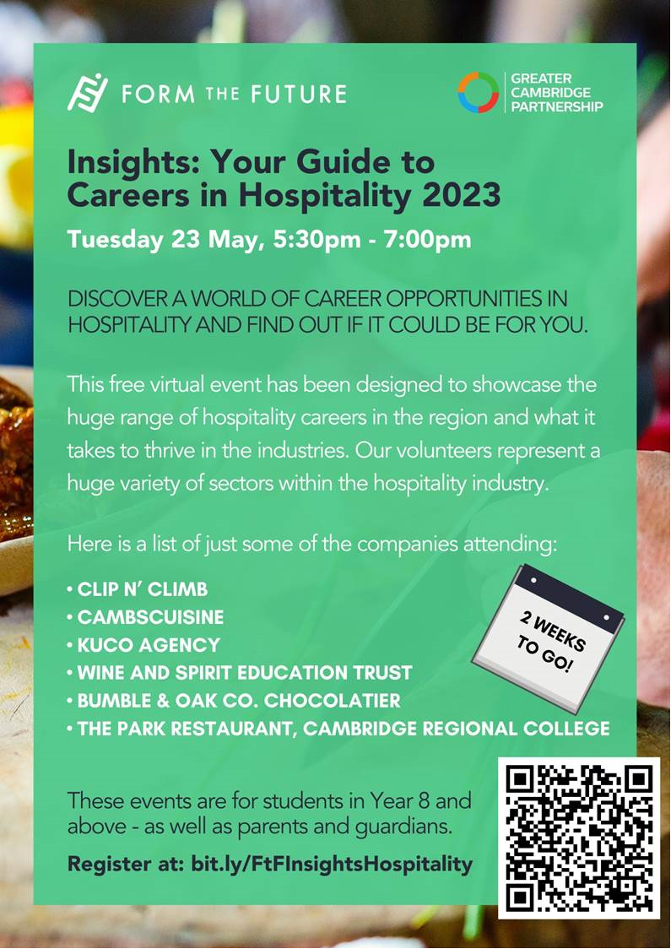
My name is Abdullah and I am an NHS doctor having graduated from the University of Oxford Medical School last summer. I currently at work at Luton and Dunstable Hospital. This is the third year I am delivering a free webinar to students planning to apply to medicine or dentistry in the coming UCAS cycle. I am writing to invite students at your school to this year’s webinar.
I ran the webinar last year and it was very well received by students and schools. I was regularly involved in outreach at my university and have worked as an admissions consultant for various companies. For safeguarding, please see the end of the email.
Please circulate this invitation to the head of sixth form and eligible students. Please note spaces are limited to Year 12/13/gap year students who will be applying in the next UCAS cycle.
The seminar will be delivered entirely by me. It will cover the personal statement, strategically selecting universities and the admissions tests. You won’t hear my advice and insight into the process anywhere else. There will also be a chance to ask any questions. It will run twice on the following dates:
Thursday 25th May 18:00 – 19:30
Saturday 10th June 18:00 – 19:30
Please register using the link below:
https://docs.google.com/forms/d/e/1FAIpQLSdxmZ6wFb1_984e6-K0Fs7AtNbKXZ5iCCPJsipAMf5voqN3Gw/viewform?usp=share_link
Best wishes,
Abdullah Khalil
Safeguarding policy:
1. My Enhanced DBS (including child workforce) is available and can be provided upon request.
2. I have completed child protection training as part of my clinical practice.
3. Link to the seminar can be provided to a member of staff and parents upon request and they are welcome to join.
4. Seminar will be recorded. Settings will be set such that participants video cameras are disabled.

Are you interested in kick-starting your career and gaining work-experience with a world renowned professional services firm? If so, you do not want to miss this opportunity!

Did you know that KPMG is one of the largest professional services companies in the world? With over 227,000 employees across 146 countries, their work spans five major areas of Finance and Personal Services; they Audit some of the UK’s biggest companies and their people in Consulting, Deal Advisory, Tax & Law, and Technology & Engineering work, with clients (from the smallest of start-ups to international mega corporations) across every industry imaginable. One of the ‘Big 4’, KPMG pride themselves on being a diverse and inclusive workplace.

KPMG are hosting a work-experience day on Tuesday 30th May from 10.00am – 4.00pm, and we would love for you to attend. During the day, you will have the opportunity to learn key employability skills, such as how to communicate your message and build your personal brand. You will also have the chance to meet KPMG colleagues to hear about their career journeys and even complete a business pitch challenge! If you are unsure what you want to do when you finish school/college, or if you would like to explore more options, then this session is perfect for you. The KPMG Student recruitment team will also explain the different career paths into KPMG.

This work-experience day is a fantastic opportunity for you to gain valuable insights into the world of work and build your professional network, not to mention a great addition to your CV. Plus, you can join us from anywhere in the country, as the event will be held on Zoom.

So, what are you waiting for? Sign up today and take the first step towards your future career with KPMG!

Sign-up link: https://www.surveymonkey.co.uk/r/XV2HSGP

Best regards,

Kelly | Young Professionals

Live! vacancy which is being offered to school leavers.
If there is any interest, can you please ask that they send their CV to the below contact with a c.c. to me.
Kelly​ | Brumbill

Talent Aquisiton Advisor

A R D O N A G H S P E C I A L T Y

Kelly.Brumbill@Ardonaghspecialty.com

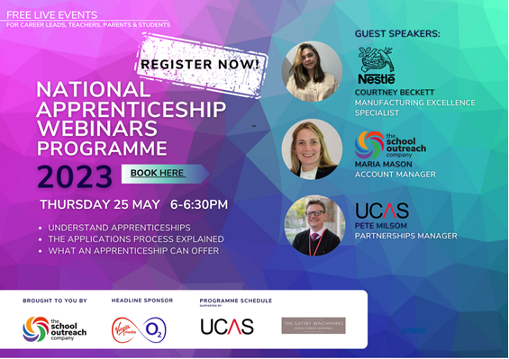
EXPLORE WORK EXPERIENCE PROGRAMME | RTPI
The Royal Town Planning Institute (RTPI) are launching their summer work experience placements for students aged 16+. Students will have the opportunity to take part in a 5 day in-person planning placement with a local employer to them during July 2023.
This is a fantastic opportunity for students to experience first hand a practical working environment, meeting business professionals and taking part in activities that will develop their skills.
Students will need to apply before 2nd June whereby after application screenings will take place and students will be selected. Thereafter Pathway CTM will work on connecting them with an employer for their placement.
Places for international students in UK dental schools are very competitive.
Good quality work experience is a vital part of a successful application, especially if it is both observational and practical.
Then check out the Medic Mind Dentistry Work Experience!
This full week of application help will include targeted exam support, hands-on experience in a hospital setting and interview help, led by a team of real dentists and application experts.
You will get:

- real insights into a dental career, with thought-provoking prompts.
- a motivating, supportive group learning environment.
- learn from real dentists, and learn real life skills ahead of your course.
- help with your UCAT, Personal Statement and interviews.
- stay in central London and meet other dental applicants!

